**Pretest 01**

**------------------------------------------------------------------------------------**

Create a database name is **News** with tables as below:

***TBL_News:***

|  |  |
| --- | --- |
| Field Name | Type |
| NewsId | int (Primary Key) |
| HeadLines | VarChar(20) |
| ContentOfNews | VarChar(50) |

***TBL_Info:***

|  |  |
| --- | --- |
| Field Name | Type |
| UserName | VarChar(20) (Primary key) |
| Password | VarChar(20) |

- After login the administrator should be redirected to the page (Administrator welcome page), which has the option to show all news , enter new news and to delete existing news. Web site that have some page : **Login.cshtml** , **Admin.cshtml**, **ShowAllNews. cshtml**, **DeleteNews. cshtml**, **AddNews. Cshtml**,

**Admin. cshtml**

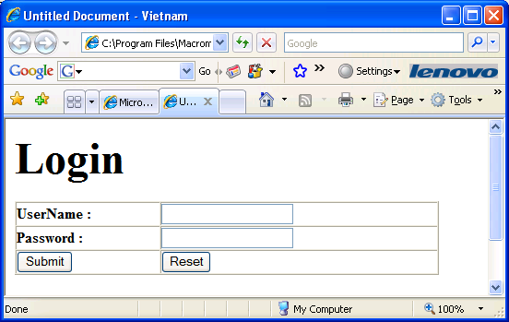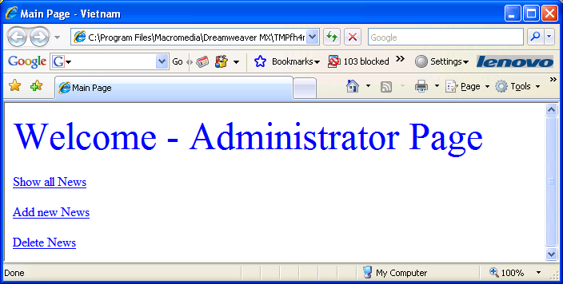

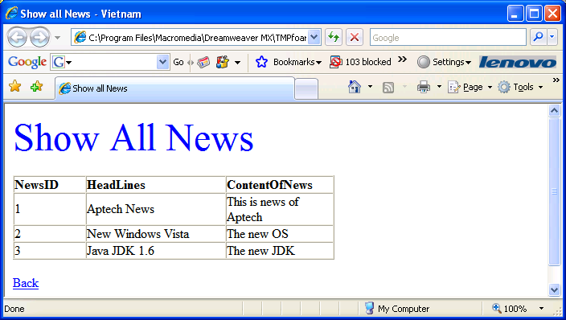

**ShowAllNews. cshtml** **–** Click Back will return to **Admin. cshtml**

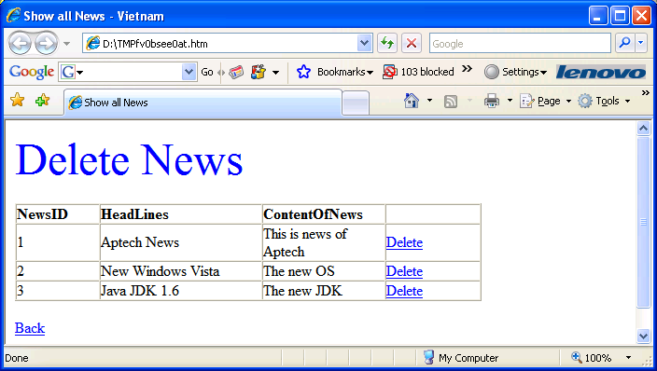

**Delete. cshtml** **-** Click Back will return to **Admin. cshtml** **– Click Delete will delete the appropriate news**

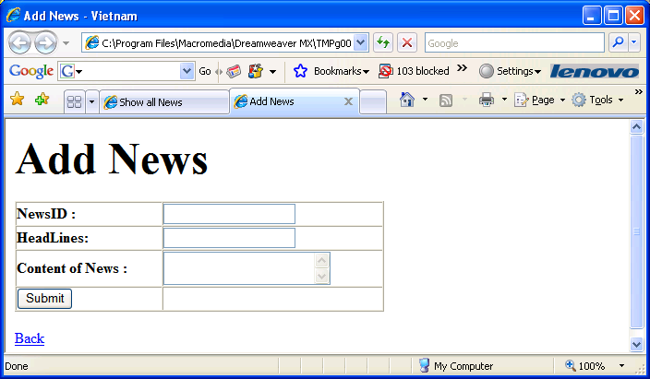

**AddNews. cshtml** **-** Click Back will return to **Admin. cshtml** **–** Click **Submit will insert the news to database.**